Give Me Five - The Child Benefit Top Up Campaign

Useful resources for Caritas Students
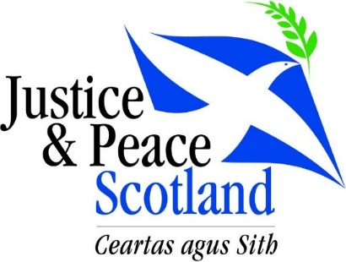
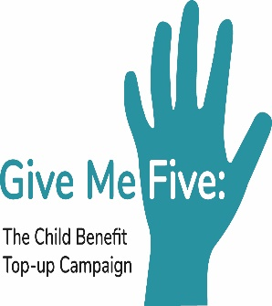
The following is a select list of items which might be useful as background information for the campaign

Catholic Social Teaching (CST)
CST is authoritative Church teaching on social, political and economic issues. It addresses the ways in which Catholics - and all Christians – might respond to the social issues facing the world. It is based on Scripture and the Church’s reflection on human experience, and it provides principles for reflection, criteria for judgment and guidelines for action. CST is an integral part of the moral teaching of the Catholic Church.
Websites:
- http://www.usccb.org/beliefs-and-teachings/what-we-believe/catholic-social-teaching/seven-themes-of-catholic-social-teaching.cfm
- https://cafod.org.uk/Pray/Catholic-social-teaching
- http://www.catholicsocialteaching.org.uk/
Videos:
- https://www.youtube.com/watch?v=ELyLdMlFdzA
- https://www.youtube.com/watch?v=GqSkkeUeV0I
- https://www.youtube.com/watch?v=HU8b0E-SPtw
- https://www.youtube.com/watch?v=2mhqLPii4CM

Option for the Poor and Vulnerable
The option (or the preferential option) for the poor and vulnerable is a way of looking at the world which gives preference to those who are poor or in any way disadvantaged. We as Christians need to have a special care for them. It does not mean that they are better or more beloved by God. It simply means that they are in circumstances which demand our attention, and as Christians our care, compassion and action.
Websites:
- https://www.crs.org/stories/pope-francis-care-poor
- https://www.cctwincities.org/education-advocacy/catholic-social-teaching/notable-quotations/option-for-the-poor/
- https://socialconcerns.nd.edu/content/4-preferential-option-poor-and-vulnerable
- http://www.usccb.org/beliefs-and-teachings/what-we-believe/catholic-social-teaching/option-for-the-poor-and-vulnerable.cfm (scripture readings on poverty)

Videos
- https://www.youtube.com/watch?v=c3gxBjtOzNM
- https://www.youtube.com/watch?v=eOHLreJheX8
- https://www.youtube.com/watch?v=AJ1t37EpQA4

Child Poverty in Scotland
More than one in four (260,000) of Scotland’s children are officially recognised as living in poverty, compared to 22% (220,000) in 2014/15. This is a level significantly higher than in many other European countries. Child poverty means growing up in families without the resources to ‘obtain the type of diet, participate in the activities and have the living conditions and amenities’ which are the norm in 21st century Scotland.
Websites
- http://www.cpag.org.uk/scotland/child-poverty-facts-and-figures
- http://www.bbc.co.uk/news/uk-scotland-39290592
- http://www.savethechildren.org.uk/about-us/where-we-work/united-kingdom/scotland
- http://www.gov.scot/Topics/People/fairerscotland/tacklingpovertyinscotland/CP
Videos
- https://www.youtube.com/watch?v=V8cNpUMvAwg
- https://www.youtube.com/watch?v=8H28bmsyfLM
- https://www.youtube.com/watch?v=cIe7BD8nKCQ

Summary of the Campaign
A good summary of the campaign and its aims and objectives: https://povertyalliance.wordpress.com/2017/04/20/give-me-five-the-campaign-to-top-up-child-benefit-in-scotland/

The Petition Process
Scottish Government Petition Website, including video and animated guide: http://www.parliament.scot/gettinginvolved/petitions/index.aspx

